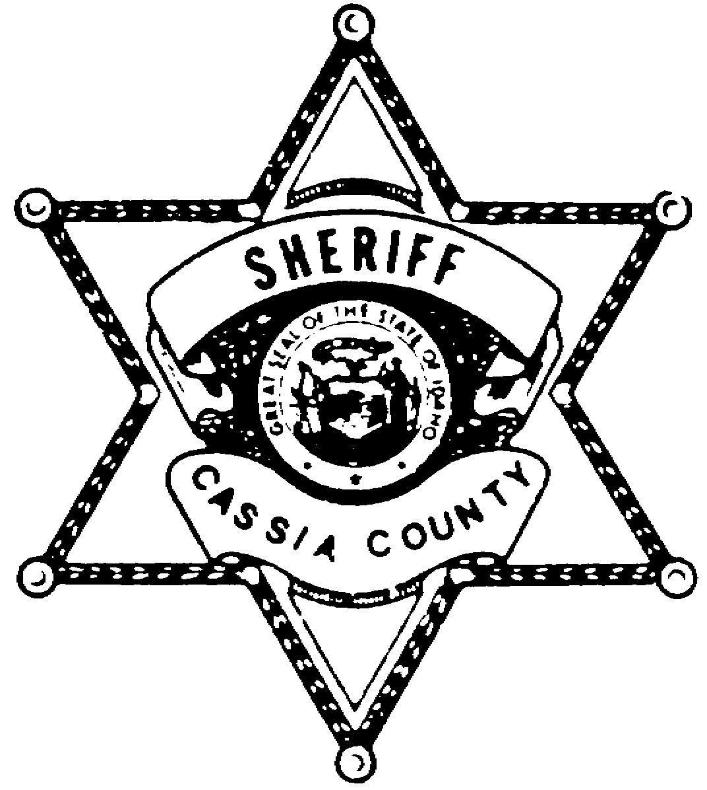

CASSIA COUNTY SHERIFF’S OFFICE

129 E. 14th Street – Burley, Idaho 83318 Ph. 208-878-2251 Fax 208-878-9797George Warrell, Sheriff

Employment Opportunity
(Cassia County is an Equal Opportunity Employer)

Full Time Position Title: Records Deputy (Secretarial Non-Sworn Position)
Application Period Closed Date: Open until position is filled
Start Date: Position is immediately available pending background approval
Salary Information: $19/hour or $39,520.00 annual wage
Employment Benefits: PERSI Retirement, Health Insurance (Medical, Dental, & Vision), 11 Paid Holiday, Plus Accrued Vacation and PTO.
General Work Hours: Monday through Friday 8:00a.m. - 5:00p.m.
Qualifications:
- High School Diploma/GED or equivalency.
- Citizen of the United States
- Must not have any felony convictions or convictions that would be considered to be a felony in the state of Idaho. Withheld Judgments on felony convictions must be disclosed in the application process, and will be considered on a case-by-case basis.
Skills:
- General computer and typing skills Organized office management
- Ability to maintain confidentiality Promptness to meet deadlines
- Excellent public relations skills Understand Criminal Law versus Civil Law
- Understanding of the criminal justice system Process reports and court documents
ESSENTIAL JOB FUNCTIONS:
- Process criminal records and criminal reporting to State and FBI. Fingerprinting for sex offender registration, concealed weapons applications, and public requests.
- Assist the public questions, reports, fingerprinting, and record requests, VIN inspections, data entry, and other assignments as needed
- Perform administration assignments
- Follow policy, procedures and safety practices
- Cross trained to do daily assignments in driver’s license, records department, and civil department
The above is intended to describe the general content of and requirements for the performance of the position. It is not to be construed as an exhaustive statement of duties, responsibilities or requirements for the position.

Hiring Process:
All applicants must submit a completed Cassia County Sheriff’s Office Application. Successful applicants must pass an oral board interview, comprehensive background check, and polygraph.

Please contact the Cassia County Sheriff’s Office or visit our website for applications.
Cassia County Sheriff’s Office
129 East 14th Street
Burley, Idaho 83318
Phone - 208-878-1107 (Monday through Friday between 9:00AM and 5:00PM).
Website – https://www.cassia.gov/law-enforcement
Employment Page - https://www.cassia.gov/departments/COUNTYSHERIFF/Employment

